

**SCHOOL OF COMPUTER SCIENCE ENGINEERING**

**AND INFORMATION SYSTEMS**

**DEPARTMENT OF COMPUTER APPLICATIONS**

**&**

**DEPARTMENT OF INFORMATION TECHNOLOGY**

**VALUE ADDED COURSE**

**ON**

**NETWORKING CARDINCALS**

**ASSESSMENT - 1**

**SUBMITTED ON: 21 – SEP - 2024**

**SUBMITTED BY-**

**AKASH KUMAR BANIK**

**PROGRAM: MCA**

**REGISTER No.: 24MCA0242**

1. A company wants to use a Linksys-WRT300N device to connect ten PCs. The Linksys device should automatically assign each PC an IP address. Implement this scenario using a Cisco packet tracer.

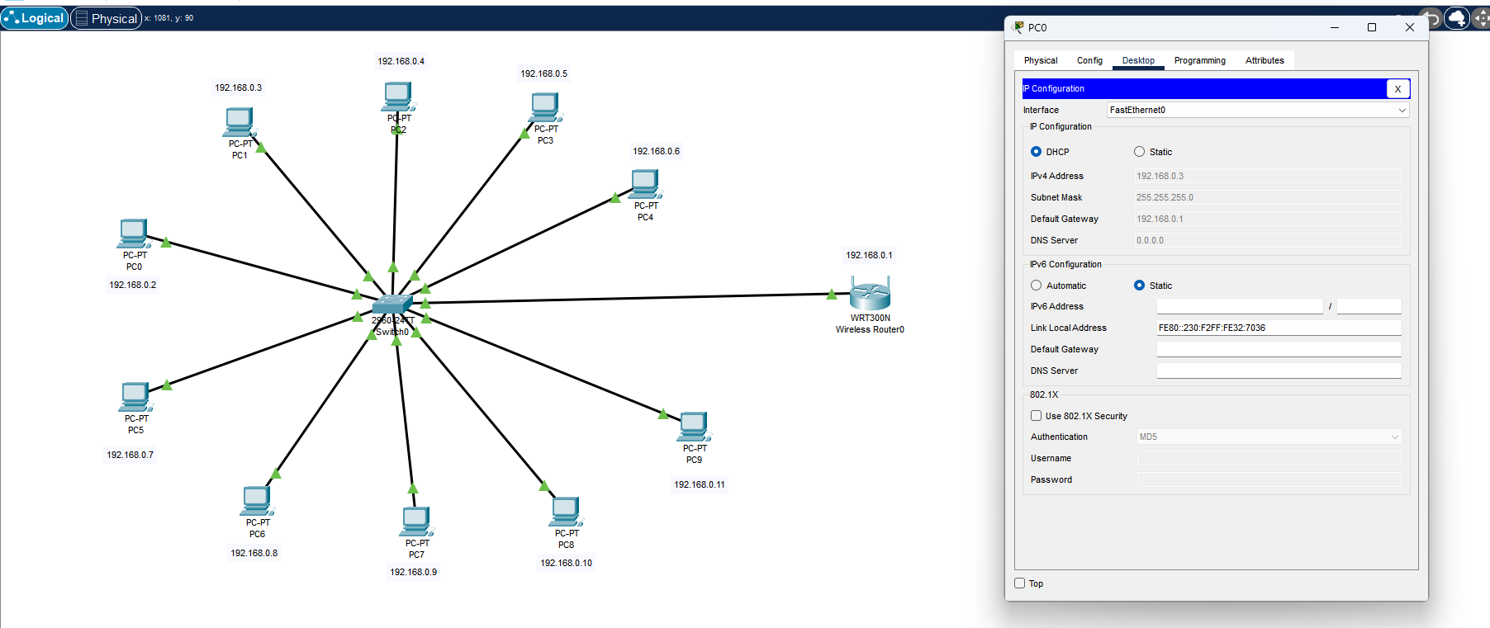

1. Configure a client-server paradigm with DNS, Web, and FTP servers. View the client/server traffic sent from a PC to all servers when requesting web and file transfer services.

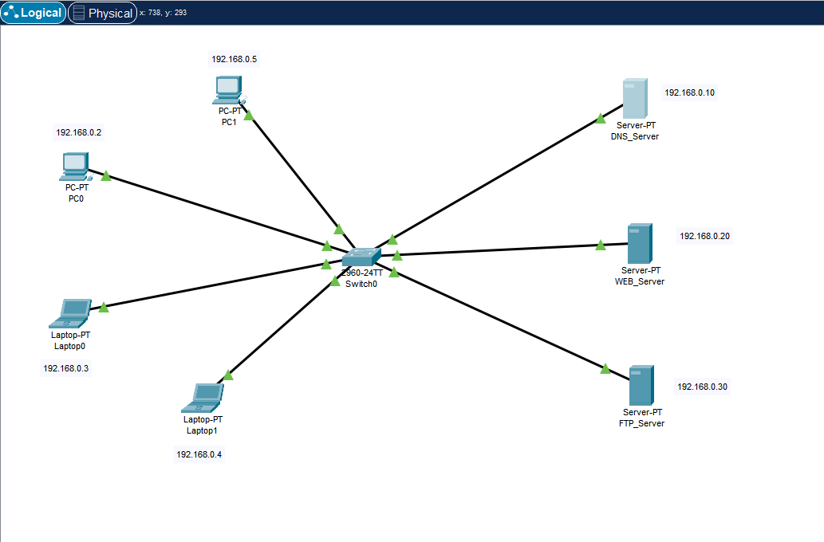

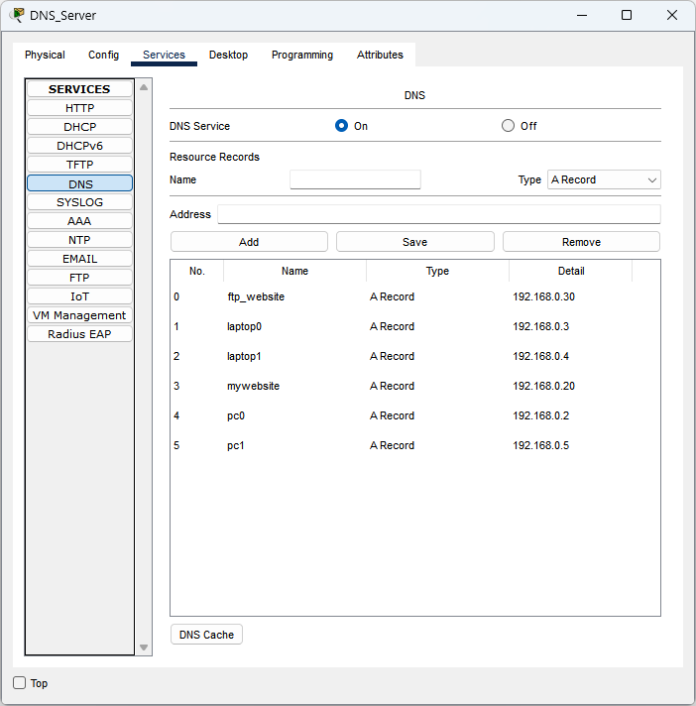

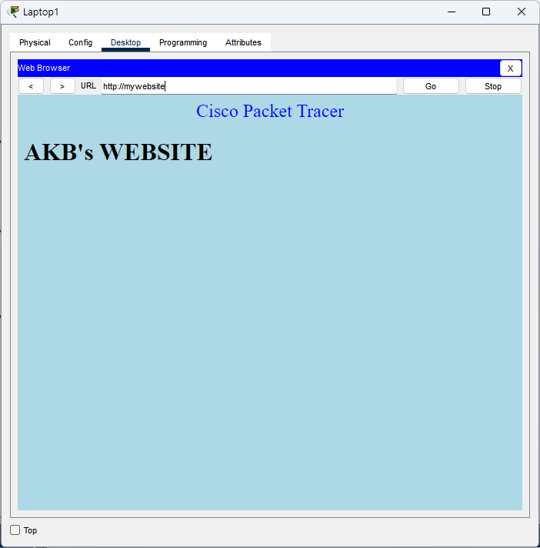

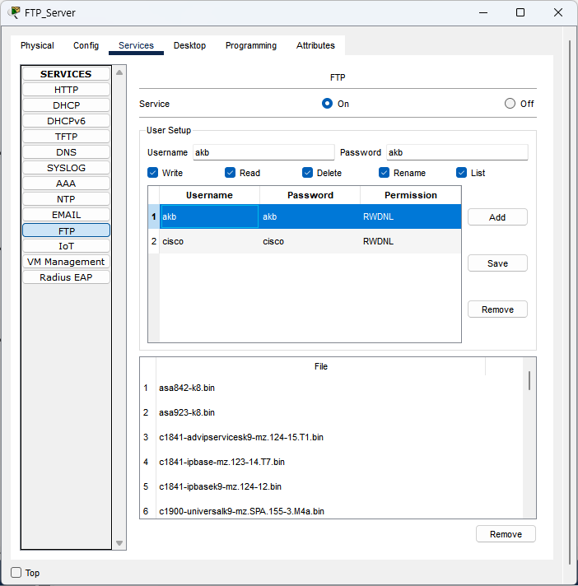

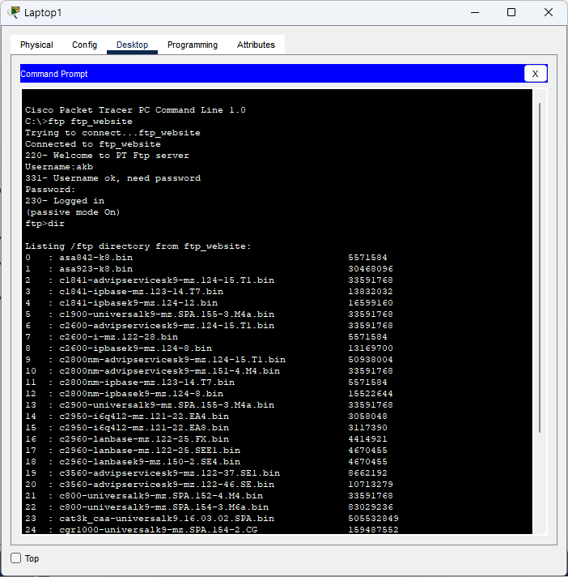

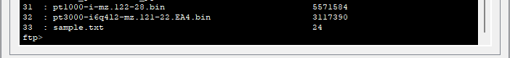

1. Implement the simulation of the Access control mechanism using three subnets namely students, faculties, and management.

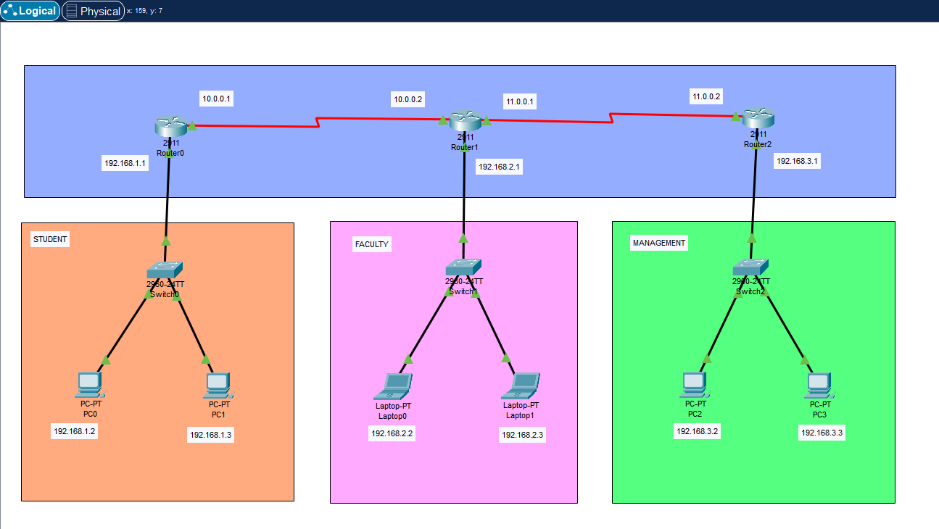

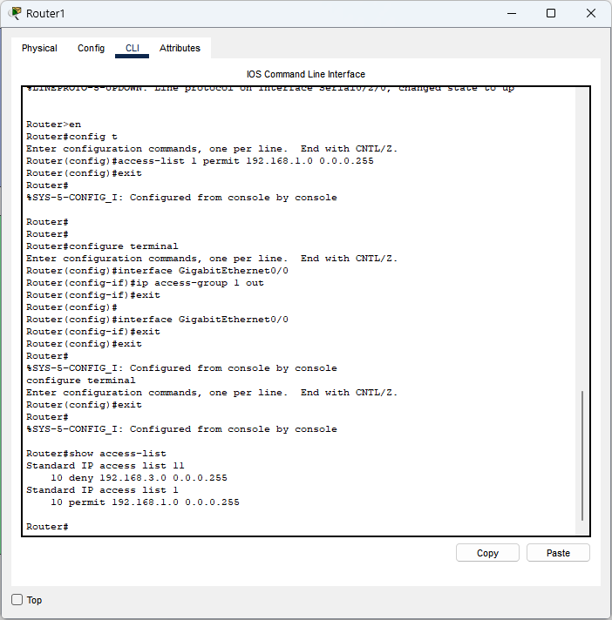

1. Create four class C subnetworks and show the traffic sent from one subnet to another.

